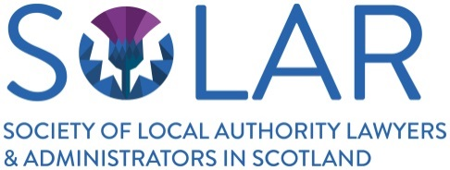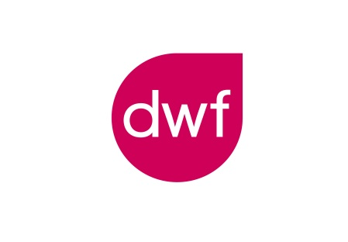

THE SOLAR ADMINISTRATION TEAM OF THE YEAR AWARD 2018
SPONSORED BY DWF

Recognising the talent and good practice followed by administrators in local authorities in Scotland, SOLAR has developed an Award scheme to celebrate success within the Local Government Administrative Services sector.

This year, we are delighted to announce that the Award is being sponsored by DWF and with their support nominations are now invited for The SOLAR Administration Team of the Year Award 2018.

The SOLAR Award 2018 ceremony will take place at the SOLAR Annual Conference Dinner in Clydebank on 15th March 2018. This will be an opportunity to celebrate the success of those working within Local Government Administrative Services, to share and showcase good practice and to recognise those teams of local government administrators who have gone the extra mile in carrying out their work.

Nominations - Criteria

The Award is open to all Corporate members of SOLAR although restricted to one entry per Council. Submissions are invited in writing (up to 1500 words) showing that participants have worked as a team to provide service excellency and met one or more of the following criteria:

- Implemented new systems, practices and procedures to improve the work of the team and/or its service to customers
- Worked to improve the effectiveness of Members as elected representatives, supporting their work both centrally and within localities
- Demonstrated best practice in a field of local authority specialism
- Innovated with reduced resources in challenging financial times

Application process and deadlines

- Electronic Written Entries must be submitted by email to Diane Campbell (d.campbell2005@btinternet.com) by 19 January 2018.
- Shortlisting will take place by 8 February 2018.
- Shortlisted nominees will be announced in February and invited to attend the Award Ceremony.
- The Award Ceremony will take place and the winner will be announced at the SOLAR Annual Conference Dinner on Thursday 15th March 2018 at the Beardmore Hotel, Clydebank. Two representatives of the shortlisted teams will be the guests of sponsors DWF at the Dinner.

The Judging Panel

The submissions will be judged by a panel of three judges with experience and in-depth understanding of local authority administrative services and the current challenges of working in the public sector.

November 2017

